Changes required to implement addition/updation of lucene fields in lucene search

It includes 2 components

1. Indexing
2. Searching
3. **Indexing:** There is one class with name PmSearchService and it is an implementation of PmSearchServiceRemote interface. This class is responsible for invoking search and refresh index operations. Also, there is one cron-job class with name PmObjSearchCron and it invokes cronAction to update indexes.

Indexing is working from SrmSearchEngine class under createIndexingSearch method.

Flow is like below:

Read search.properties(if available) -> do indexing of fields present in it.

Read indexes (if search.properties not available) -> create search.properties with indexed data.

Using latest time stamp in srm.properties create a query and hit maximo API for data.

**Split maximo data and do indexing of it with key as field (from search.property) and value as maximo data value.**

1. **Searching:** Searching is working from two aspects:

PmSearchService (searchFromValue) -> SrmSearchEngine (search)

PmSearchService (simpleSearch) - > SrmSearchEngine (simpleSearch)

In **SrmSearchEngine** there is one method **buildSearchFieldsList** responsible for creating String Array of fields used for searching instead of search.properties.

After getting String array of fields to be searched for provided text, logic for single/multi language will do searching.

**Action Required to make indexing and searching work with dynamic attributes present in search.properties**

**For Indexing:** No Action required, we just need to add new field in search.properties and execute cron for changes.

**For searching:**

Need to re-write **buildSearchFieldsList** method in **SrmSearchEngine** class, to make it read search.properties for fields.

Return type of method will remain same, so no changes required in calling methods. Also, this method is private, and no other class is calling it.

Snippet of new implementation of method looks like below:

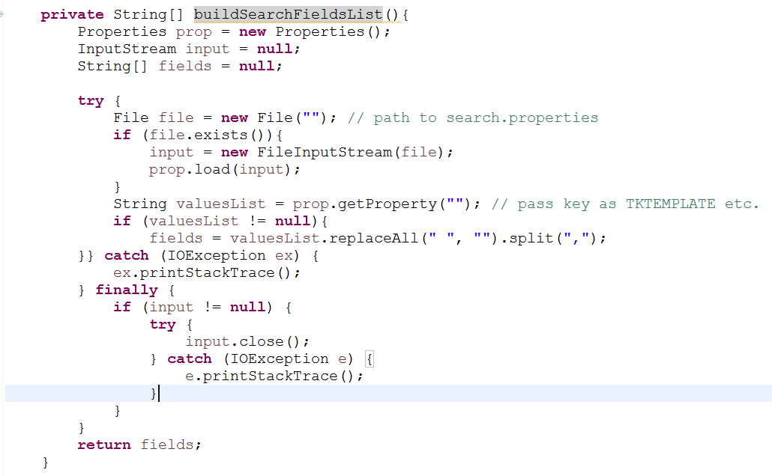

**Error Handling:**

Base error handling is already present, and to handle “fields not found” scenario’s Fuzzy Search is already present. So, we are good here.